ABC IRELAND TOUR

**Web Design and Client-Side Scripting (HDCSDEV_INT)**

Eugene McLaughlin

23325038 CHANGHUN YOO

23326417 Hao Ji

23332204 JUAN HE

# Table of Contents:

1. Project Summary
2. Design Process
   1. Research & Investigation
   2. Requirements & Technical Approach
   3. Design & Wireframe
      1. Wireframe
3. Project Work
   1. Break Down of Tasks
4. Development
   1. Bootstrap Implementation
   2. jQuery Implementation
   3. Validation
   4. Optimization & SEO
   5. Testing & Responsiveness
      1. Responsiveness
   6. Website Deployment
5. Conclusion
   1. Result, Achievements, Teamwork, and Possible Improvements.
6. Reference

* Deployed Website link

1. Project Summary

We want to create a website for a travel agency called "ABC IRELAND TOUR" located in Dublin. I created this because I wanted to introduce beautiful small cities in Ireland to people all over the world.

When consumers visit the homepage, we plan to make it easy to see famous small cities in Ireland, and we plan to decorate the homepage with the colours of the Irish flag. We will also attach a map so that consumers can easily find where each city is located.

To decorate the homepage, we will use what we learned about HTML, CSS, JavaScript, jQuery, and Bootstraps, and after verifying it through a site that can be verified in class throughout the project, we will practice deploying the website.

# 2. Design Process

# 2.1 Research & Investigation

# We decided to develop a travel website after the group meeting. To introduce what we know about the culture, food and scenery of Ireland’s four major cities. The website also has a reservation service. But first, the customer must leave the message about her/him, so we can get in touch with you. The design and content of the website mainly refered to other website, as follows:

# URL: https://www.ireland.com/en-gb/

# 

# 2.2 Requirements & Technical Approch

# We planed to develop six pages include Home page, Dublin page, Cork page, Galway page, Limerick page and Contact page. In addition to the Contact page, the style of the other pages needed to be consistent. For example, use the same header and the same footer. And use the same bootstrap version to build the structure of the website.

# 2.3 Design & Wireframe

# 2.3.1 Wireframe

# Every term member drew the wireframe of the pages. As follow:

# 

# Home page(Created by CHANGHUN YOO)

# Contact page (Created by CHANGHUN YOO)

# hao-dublin

# Dublic page(created by HAO JI)

# hao-cork

# Dublic page(created by HAO JI)

# 

# Galway5.drawio

# Galway page(created by JUAN HE)

# Limerick2.drawio

# Limerick page(Created by JUAN HE)

# 3.Project Work

# 3.1 Break Down of Tasks

CHANGHUN YOO was in charge of creating the main homepage and contact page. He also designed the basic structure.

Hao Ji was in charge of creating the Dublin and Cork pages. He was creating the history, tourist attractions, and good restaurants of each city.

JUAN HE was in charge of creating the Galway and Limerick pages. She was creating the scenery, music, and culture of each city.

# 4.Development

# 4.1 Bootstrap

# Bootstrap has a lot of mature features and components. And in this website, we used Grid layout , as follows:

# In the home page,

# 

# This layout was used the medium (md) of six default grid tiers. The code is as follows:

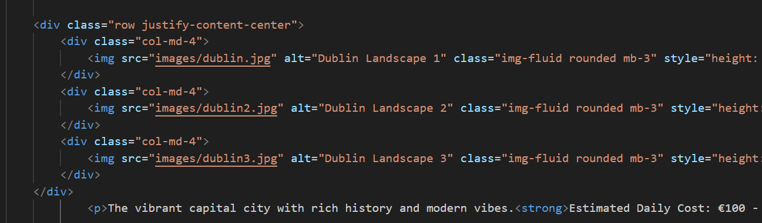

And we used Carousel Component in the Galway page, as follows:

# 

# This images were used Autoplaying carousels. The code is as follows:

# 

# 4.2 JQ

# In the Contact page, we did a basic check that email check and used the JQ to control the number of submission. This function is to prevent the user click the submit buttom multiple times and donot upload the form data to service multiple times.

# 

# 

# In the Galway page, we used the JQ to determine the keyword of search function.

# 

# When the user click the the search button, If the keyword is empty, it will be show you the tips. For example

# 

# 4.3 Validation

# We used the W3C website(https://validator.w3.org/) to validate all pages of our travel website. The website shows some errors and warnings in partial pages. There are 4 errors and 1 warning in the Cork page. The detail is as follow:

# 

# We changed all errors.

# 

# And there are 7 errors and 2 warning in the Galway page. The detail is as follow:

# 

# After changing the image name to no spaces , there are no errors.

# 

# There is a error in the Limerick page. The detail is as follow:

# 

# This error is the same mistake as Galway page. We need to change the image name to no spaces.

# 

# 4.4 Optimizatiom

# We used the Google Lighthouse to test the website, and the score is as follows:

# 

# Most of the errors show that the images id too big. So we need to use image optimizilla tool to compress the images.

# 

# We also used the Meta tags to optimize. As follows:

# 

# Optimize headings and alt text for images

# 

# 4.5 Testing & Responsiveness

# To ensure the travel website to adapt different devices, we had used the bootstrap and meta in HTML5.

# We used online tool website (https://responsivetesttool.com/ ) to ensure our travel website. As follows:

# 

# 

# 

## 4.6 Website Deployment

# Our website is deployed in the Github.